**Write your own program using arithmetic operators.**

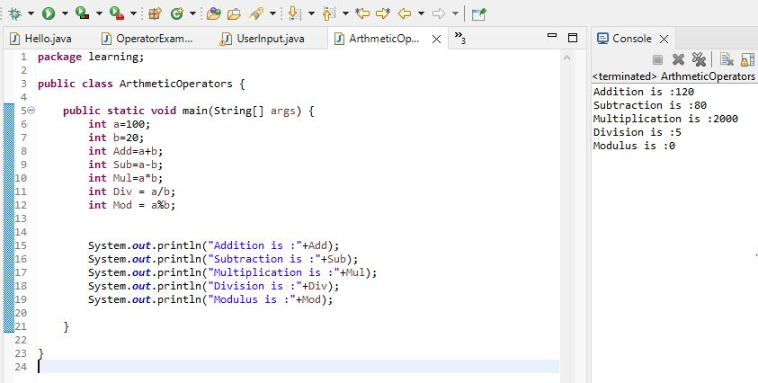

**Write your own program using arithmetic assignment operators.**

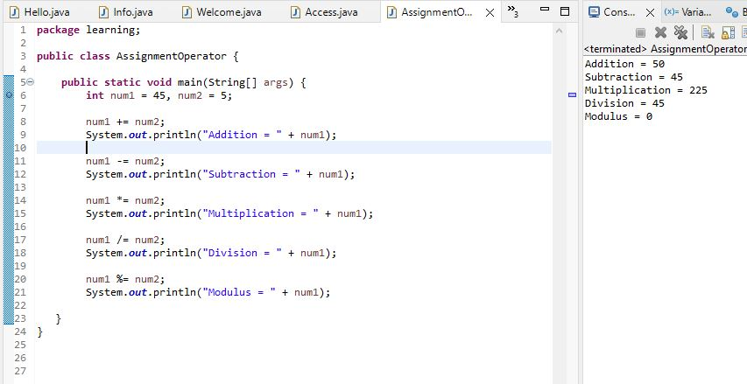

**Write your own program using relational operators.**

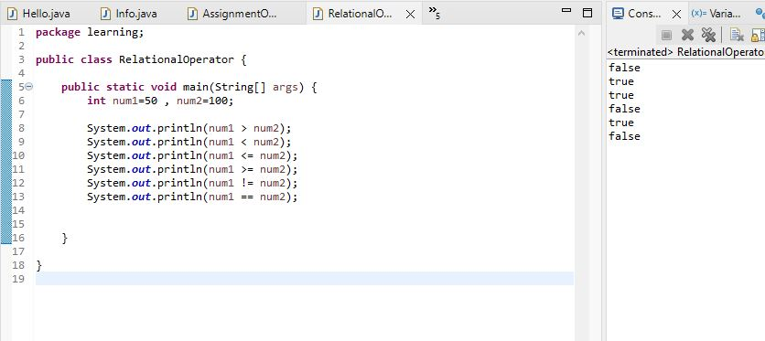

**Write your own program using logical operators.**

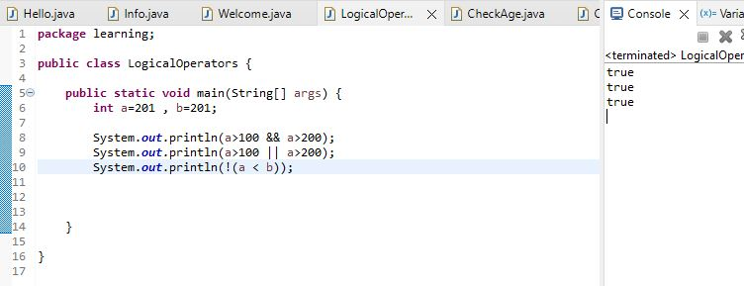

**Write a program to check age of student is greater than 18.**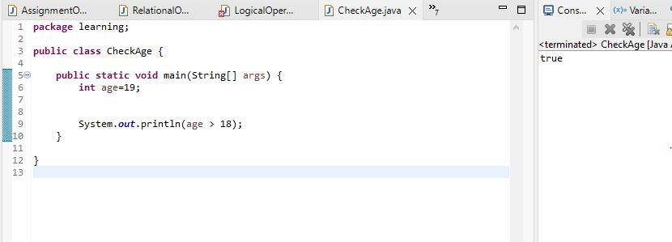

**Write a program to check number is even or odd.**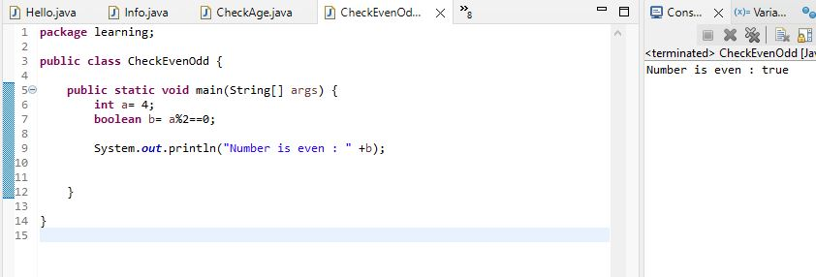

**write a program to check whether number is greater than 100 and 200.**

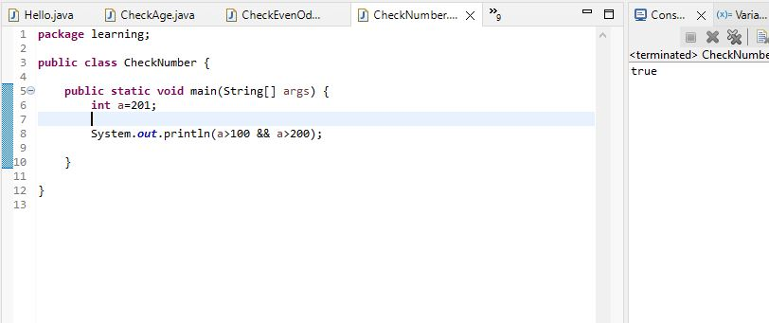

**write a program to check whether both numbers are same or not.**

